**MINOR-1 PROJECT**

**SYNOPSIS/MID/END Report**

Submitted By:

|  |  |  |
| --- | --- | --- |
| **Name** | **Roll No** | **Branch** |
| Sagar Soni | R110219116 | CSE-CCVT |

**Under the guidance of**

**Ms. Avita Katal**

**Associate Professor-Senior Scale**

**Systemics Cluster**



School of Computer Science

**UNIVERSITY OF PETROLEUM AND ENERGY STUDIES**

**B. Tech CCVT, 5th Sem, Batch: 2019-23**

**Approved By**

**Ms. Avita Katal**

**(Assistant Professor-Senior Scale)**

(**Ms. Avita Katal**) (**Dr. Neelu Jyoti Ahuja**)

**Project Guide Cluster Head**



**School of Computer Science**

University of Petroleum & Energy Studies, Dehradun

**Synopsis Report (2021-22)**

# Project Title:

An Improved Ant Colony Optimization Algorithm for Recommendation of Micro-learning Path

# Abstract:

The concept of using an upgraded ant colony optimization algorithm to recommend a micro-learning path. Micro-learning is a new learning approach that uses little micro-learning units to enhance learning in a short amount of time. Each micro-learning unit is made up of a single little knowledge unit that can be learned in a short amount of time.

Micro-learning is chosen over other learning approaches because it organises and reorganises the learning path based on the learner's transition. A suitable learning path containing a sequence of micro-learning units is recommended to the student in order to improve learning efficiency, which is optimised according to his/her transition.

The suggested method can recognise learner learning transitions of knowledge level, knowledge area, and learning goal during the micro-learning process based on the learner's operation. The ant colony algorithm's premature problem is handled by optimising the pheromone initialization and updating process. The algorithm has a high efficiency in micro-learning path recommendation, according to the findings of the experiments.

# Introduction:

Micro-learning is a new type of e-learning that was first introduced in 2005.

It is made up of little or brief learning units. Small learning units and short-term learning activities are addressed. Micro-learning path recommendation based on an improved ant colony optimization method. Micro-learning is a novel learning technique that, thanks to its micro-learning units, may be utilized to support learning in a short amount of time. A little knowledge unit makes up each micro-learning unit. Micro-learning is more adaptable than other learning styles when it comes to structuring or reorganizing learning paths based on the learner's transition. The suggested method can recognize learner learning transitions of knowledge level, knowledge area, and learning goal during the micro-learning process based on the learner's operation.

Multiple Micro-learning units provide a learning path that can assist learners in achieving their learning objectives quickly and without risk. The number of relevant micro-learning units may be extracted, and a series of suitable learning paths can be organised for target learners to increase their learning efficiency, based on learner differences and correlation variables among micro-learning units and learners.

In our project, we put a lot of emphasis on self-study, which is a component of the ACO algorithm that is utilised to improve the efficiency of micro-learning path recommendations. The learners are split into three levels: beginner, medium level, and senior. The learning modules are classified into three levels: easy, normal, and challenging. The learning state of learners is appraised during the learning process based on their test results, and then appropriate learning goals are retrieved in order to adapt to the transition of test outcomes.

# Literature Review:

The authors in [1] have proposed an approach of recommending micro-learning path based on

Improved ant colony optimization algorithm**.** According to the operation of the learner, the authors'

suggested algorithm can recognise learner's learning transitions of knowledge level, knowledge area,

and learning aim.

The authors of [2] suggested a method for recommending student courses through the use of ACO.

They demonstrated that their methodologies are effective in tackling several optimization problems

after using ACO. The authors present ACO-based hybrid filtering. They demonstrated a new hybrid

approach (HA) strategy.

The authors of [3] developed a strategy to recommending learning paths that uses intelligent models

to organise the enormous number of technical and learning resources into one crucial feature of the

learning path.

The authors of [4] suggested a mechanism for providing a solution to real-world situations using traditional methodologies. It gives a possibility for adopt the  dynamic changes inside the problem

# Problem Statement:

In today's environment, everyone must decide how to go in order to achieve their objectives. Since learning should be both intelligent and diligent. As a result, there should be a need to modifiy our current learning system to micro units of learning in order to be more smart and efficient. We have built micro units that will also promote micro learning paths, and the purposed algorithm is best suited for this instance.

# Objectives:

* To develop a platform where students will get recommendations according to their learning goals.
* To improve the current system of online learning platform by using micro learning units.

# Methodology:

Figure 1 describes the flow chart of the algorithm which consists of 7 modules. The data from each modules is send/received from MySQL.

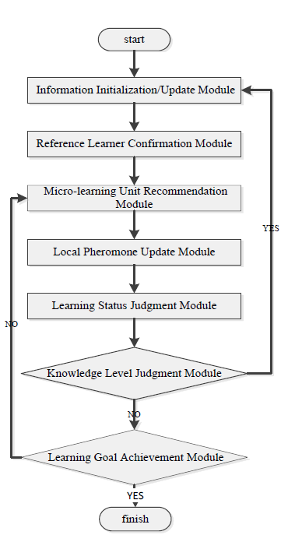

fig 1: flow chart of the project

Figure 1.2

1. Information Initialization/Update Module:

New students must choose their knowledge area based on their interests. Second, in order to certify their knowledge level, new learners must complete a level test learning unit.

Finally, learning objectives are determined based on the learner's knowledge level.

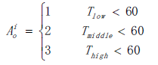

(1)

1. Reference Learner Confirmation Module:

The similarity of learners contains two aspects, the basic characteristics and the learning records. The correlation factor Fkt between learner Sk and St is:



(2)

According to the algorithm's test, the learners who have a high degree of similarity to the target learners will be considered the target learner's reference learners.

1. Micro-learning Unit Recommendation Module:

This module is used to recommend learning courses according to the transitions made by the target learners.

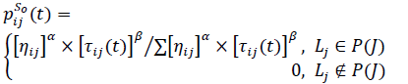

(3)

1. Local Pheromone Update Module:

Local updating strategy is point to updating the pheromone concentration according to the test score while the learner finishing the study of one micro-learning unit.



(4)

1. Learning Status Judgment Module:

The learning status is to represent the learner's mastery of knowledge and the compatibility of the current learning path.

The details are described as follows.

* Stationary status - If the test score is excellent, it means the learner's present learning route is appropriate. The target learner will continue on his or her current path of study.
* Active status - If the test result is good or fair, the current learning route is not appropriate for the target learner. The target learner's knowledge level will then be adjusted, and a suitable learning route will be suggested.
* Degradation status - If the test score is fail, it means the current micro-learning units' knowledge level is incorrect for the target learner. The target learner's learning condition is deteriorating.
* Up-gradation status - If the comprehensive exam results of three successive learning routes are good, it shows that the present unit's knowledge level is not appropriate for the target learner. The target learner's learning status is up-gradation.

1. Knowledge Level Judgment Module

If the present learning status is degradation or up-gradation, the learner's knowledge level will change, and the learner's judgement of information will need to be updated.

1. Learning Goal Achievement Module

Each micro-learning unit's final test result is used to confirm whether a target learner has achieved the learning goal. If the target learner completed 90% of the micro-learning units in the current original learning path and the test results were good (excellent, good, medium, and poor, respectively), the target learner met the learning goal.



(5)

# Experimental Setup

Operating System: Microsoft Windows

Processor: 11th Gen Intel® Core™ i7-1165G7 @2.80GHz

Disc Drive: SSD

RAM: 8GB or higher

# Class Diagram

Fig 2: Class diagram

1. **Result:**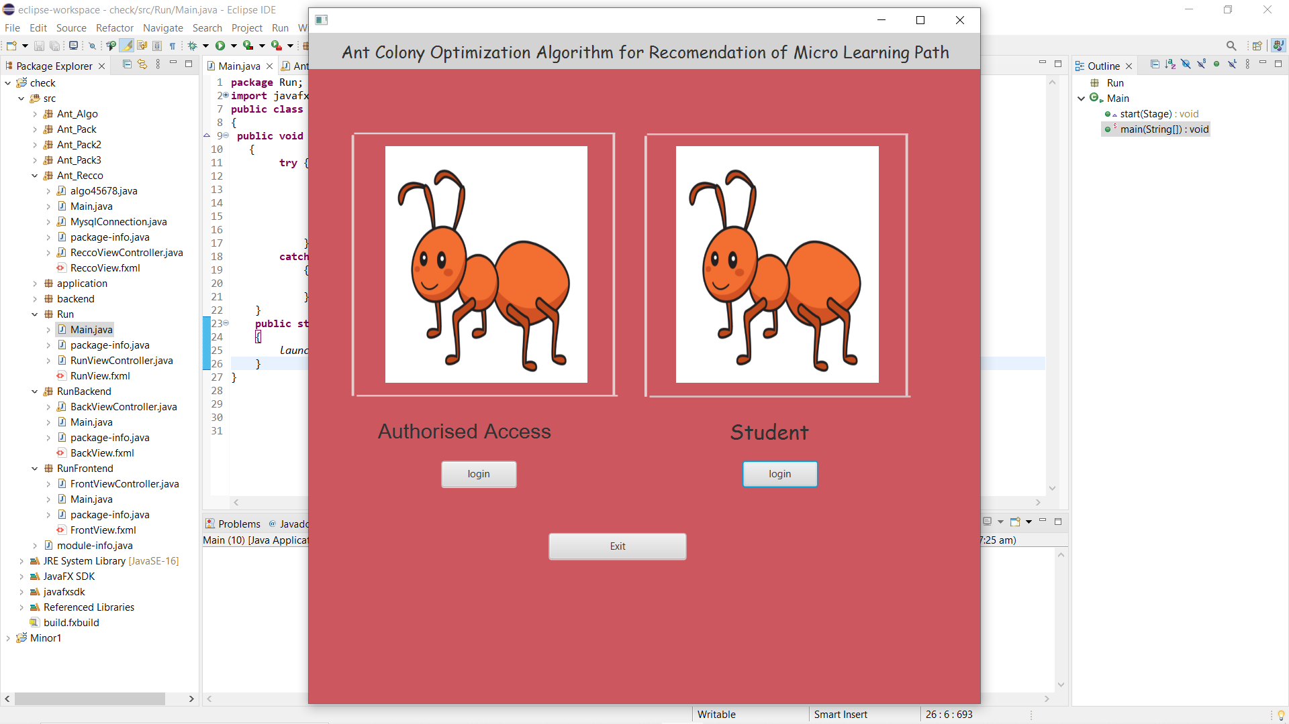

Fig: 1.1 (It represents home page)

We have two options here Authorized Access and Student Authorized Access is used by organization and student access will be used by new enrollments.

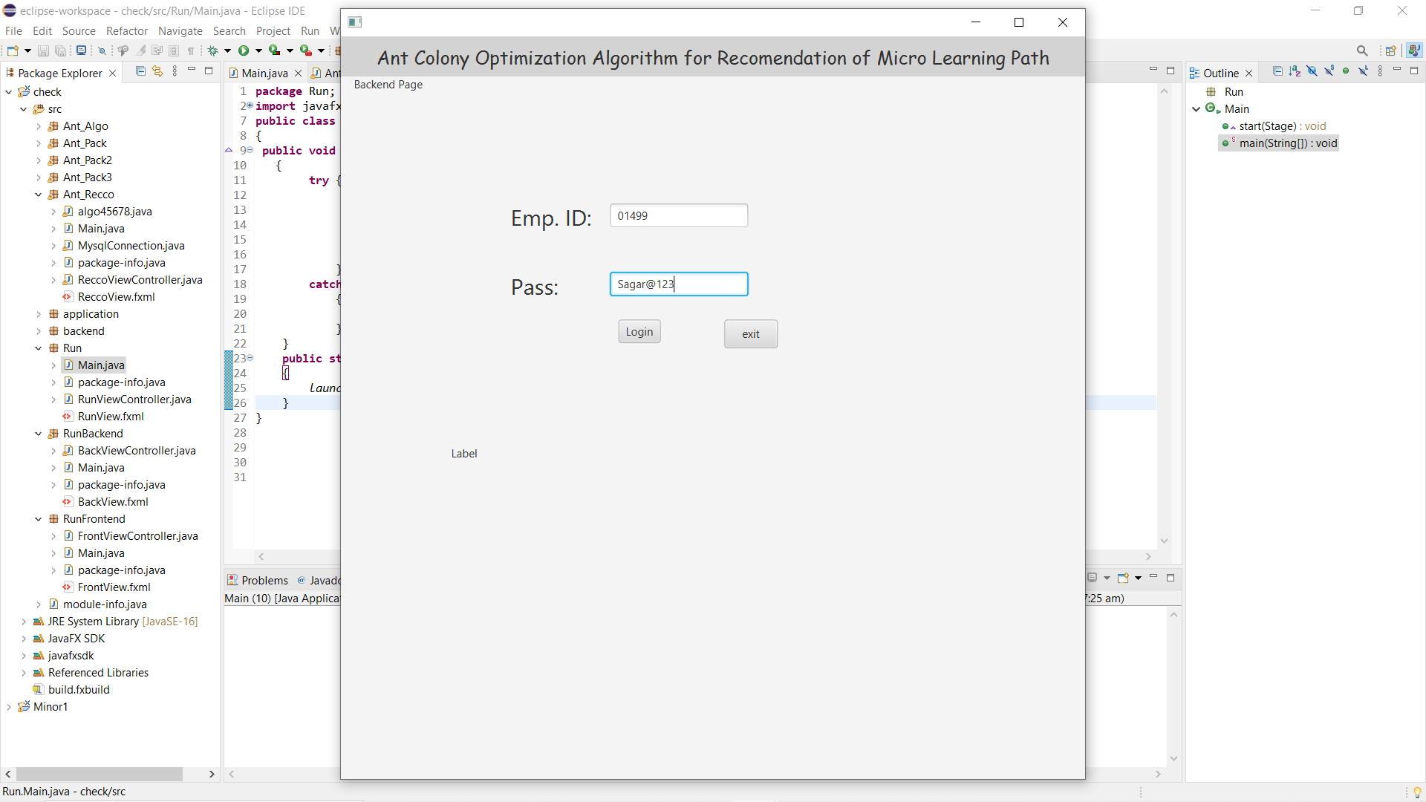

Fig: 1.2 (It is verification and login page for Organization employees)

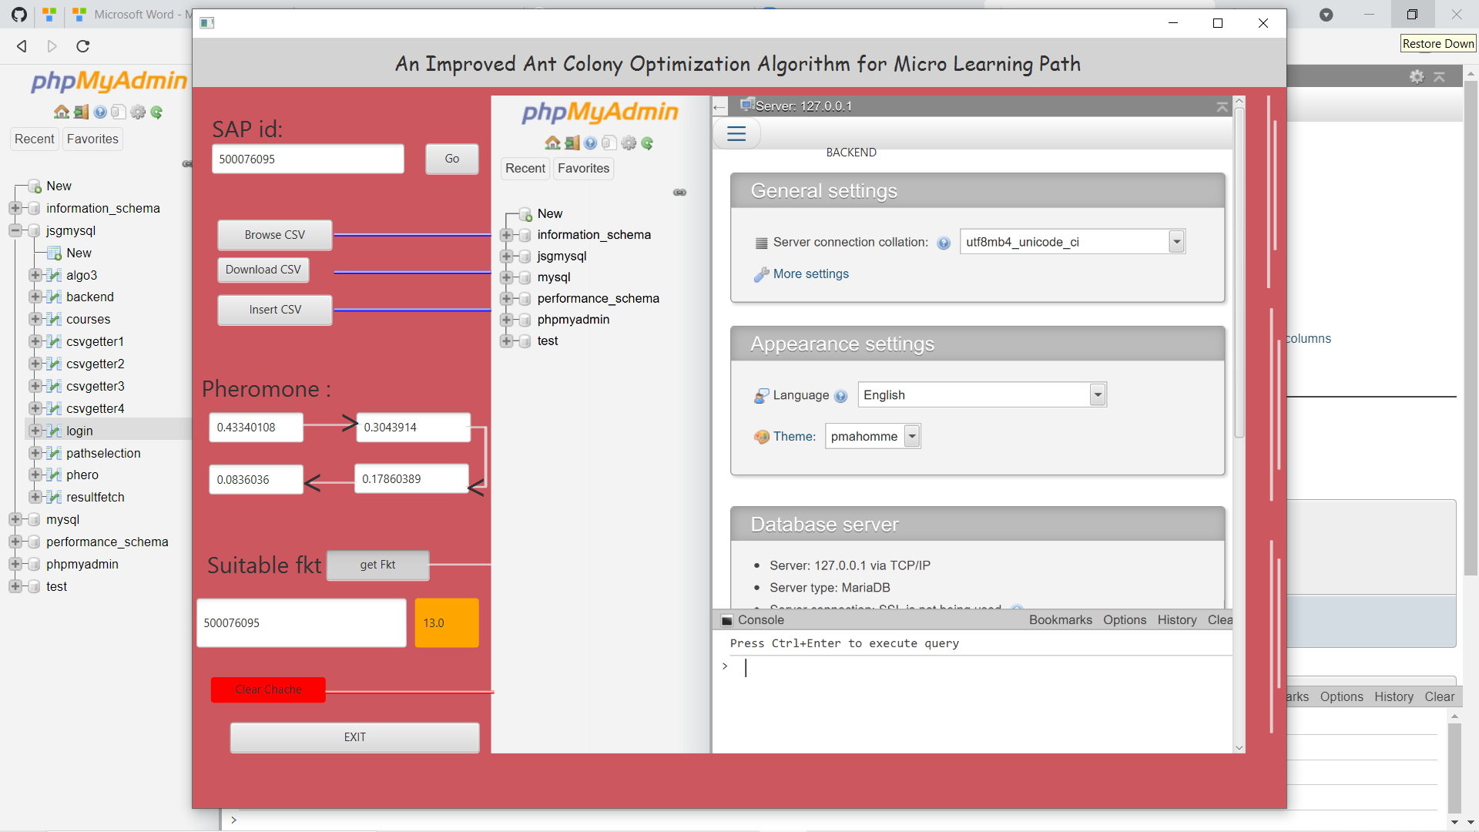

Fig: 1.3 (It is the server side or the Backend Page where student records and test records are maintained in a systematic order.)

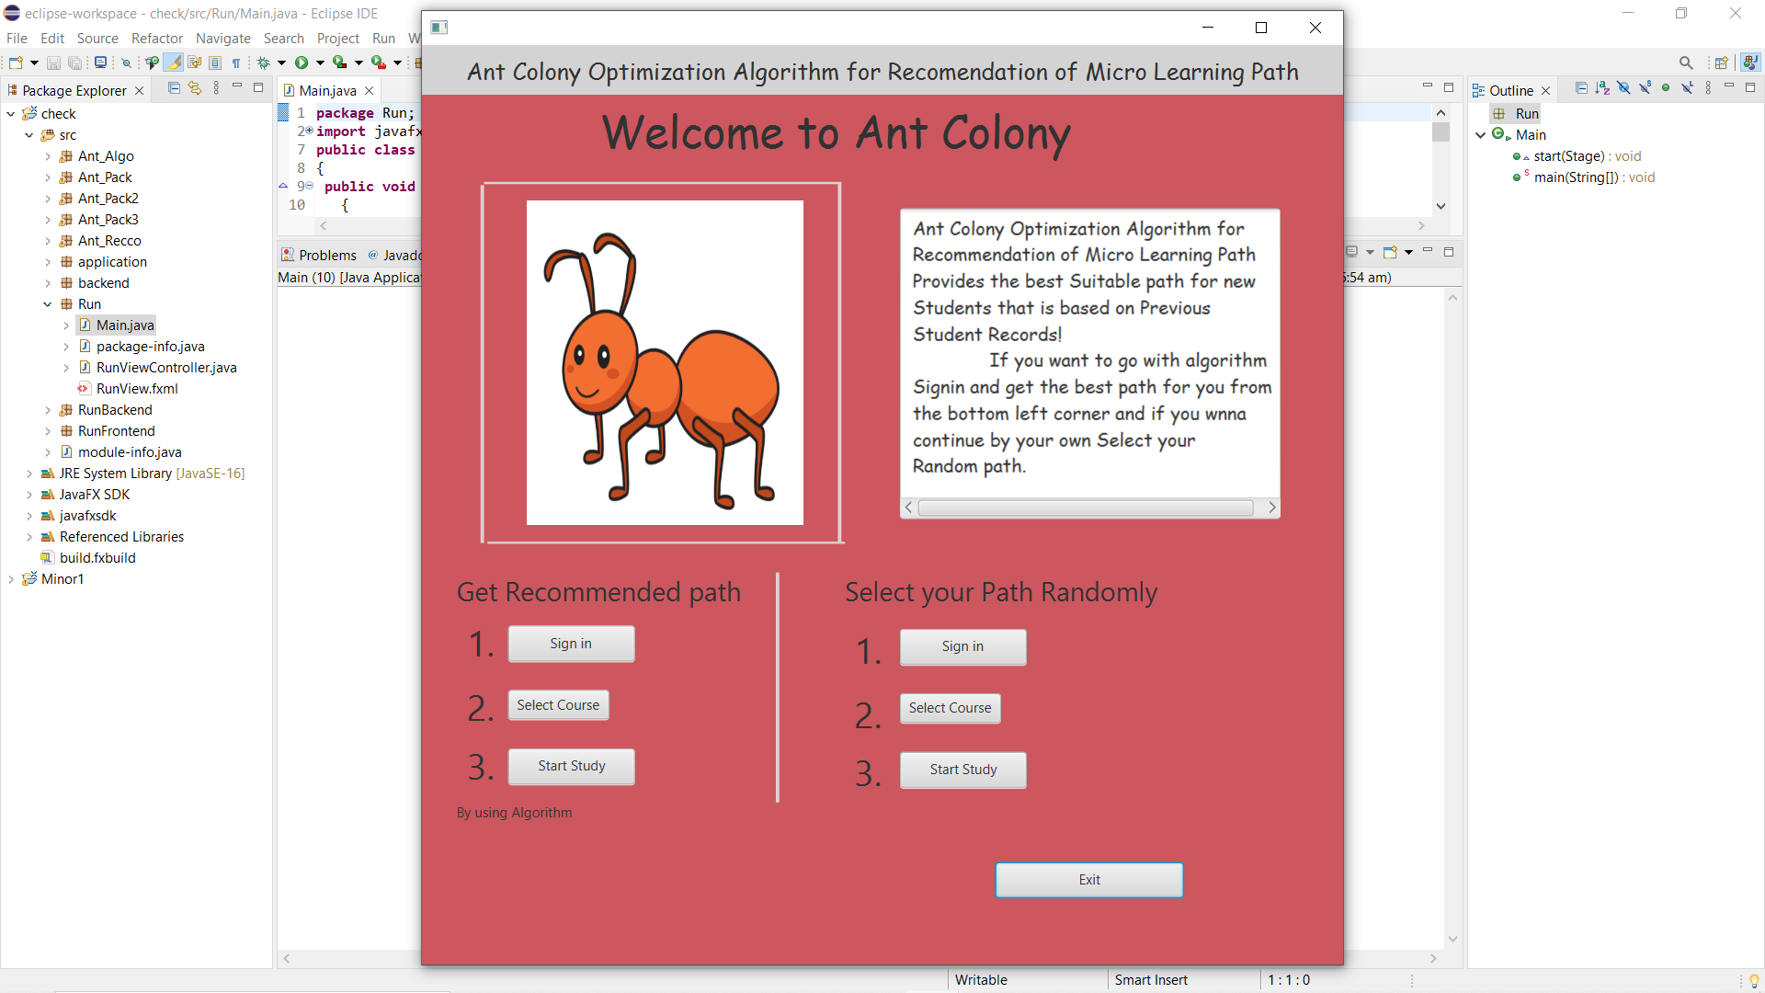\

Fig 1.4 (It is the choice section where a student have 2 options either he/she can select recommended path or he can select its random path.)

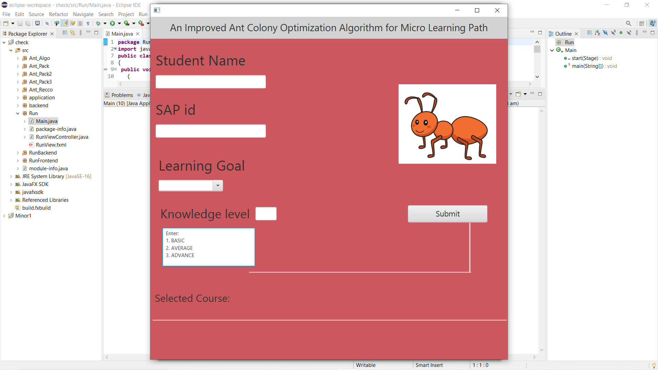

Fig: 1.5 (Sign In Page)

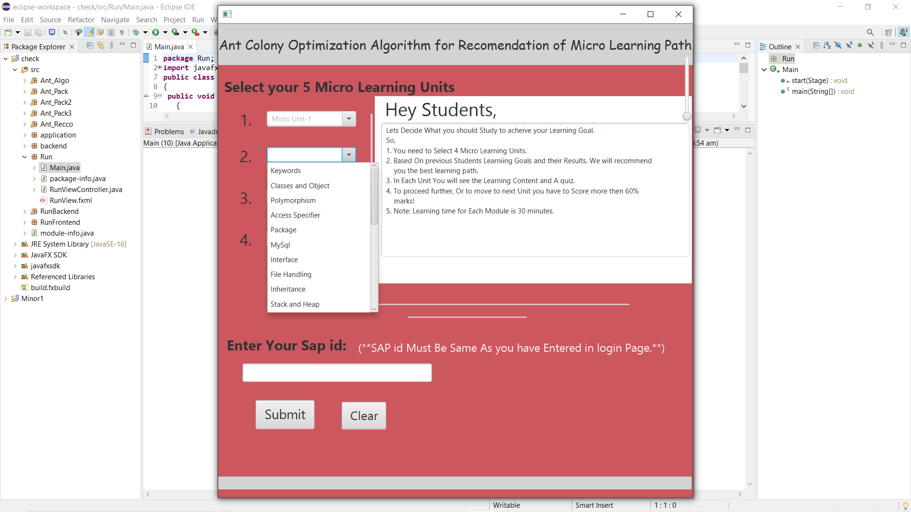

Fig: 1.6 (Module selection Page: Student need to select the modules or courses)

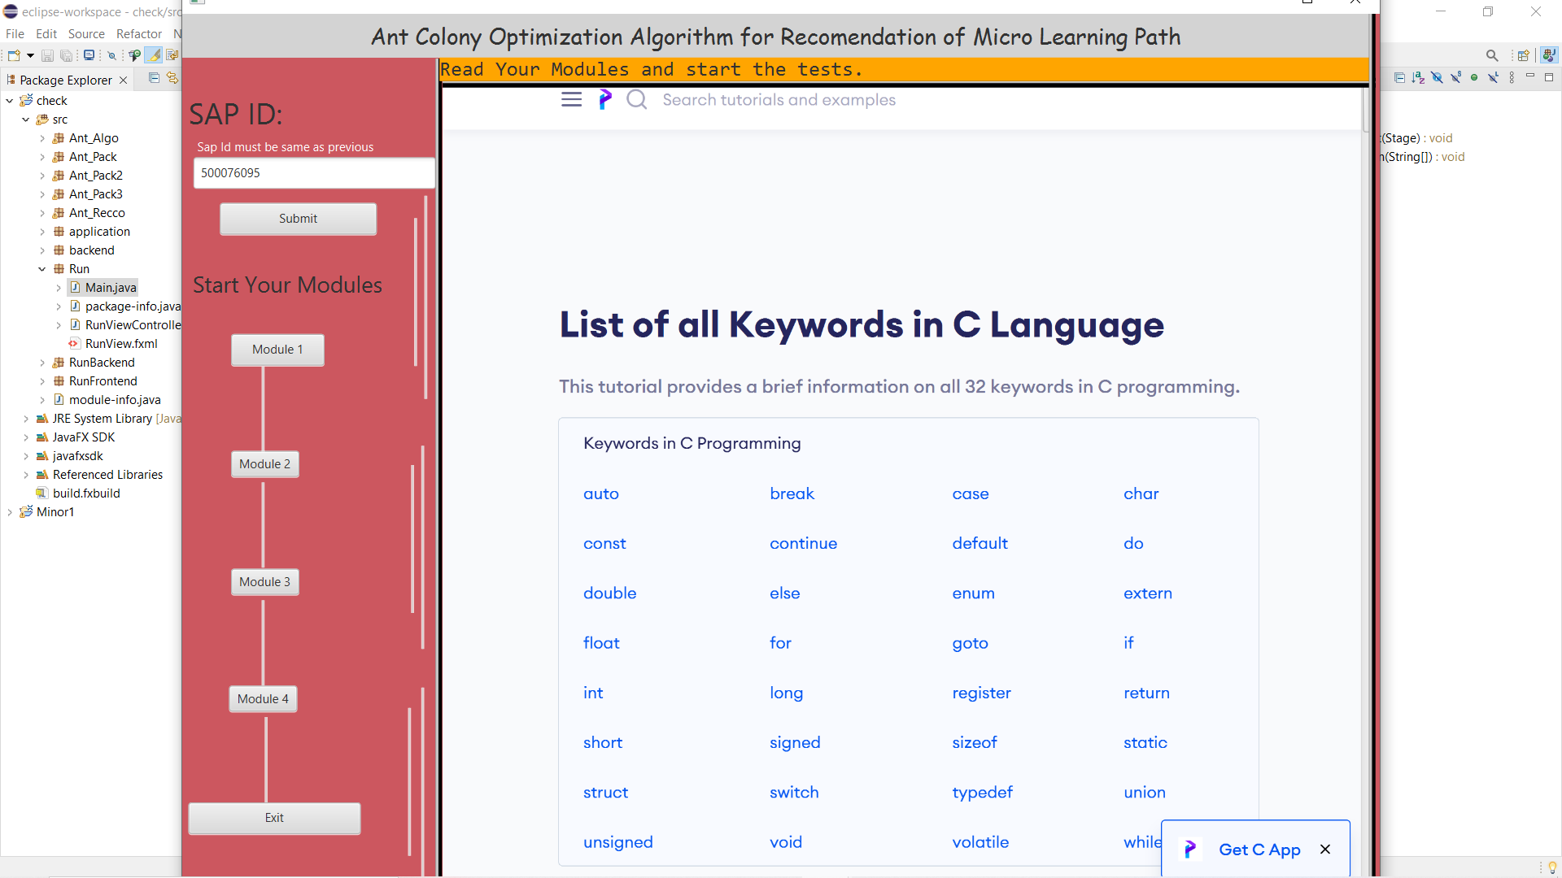

Fig: 1.7 (Student Interface: The students will start there courses that they have selected and then they need to give the test after that next course can be started.)

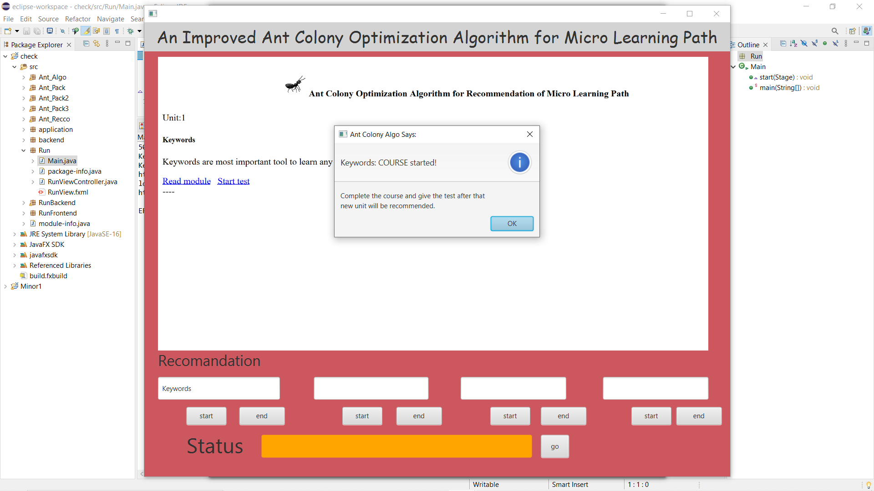

Fig: 1.8 (Path Recommendation: According to the algorithm the best path will be recommended.)

# TimeLine Chart

Fig 7: time line chart

# 10. References & GIT link

[1] 2016 IEEE International Conference on Computer and Information Technology.

[2] Microsoft Ignite - <https://docs.microsoft.com/en-us/archive/msdn-magazine/2012/february/test-run-ant-colony-optimization>(15-09-2021)

[3]2012 International Conference on Computer Science and Electronics Engineering (23 April 2012).

[4] T. Hug, M. Lindner and P.A Bruck, “Micro learning: Emerging concepts, practices and technologies after e learning,” In Proc. Of Micro learning 2005, Learning & Working in New Media, pp. 45-53, Australia, Innsbruck Innsbruck University Press, 2005

[5] **Git Link:** https://github.com/sagarsoni1234/Ant-Clonoy-Optimization-Algorithm-For-Recomendation-Of-Micro-Learning-Path